Lec – 6
Column Storage databases
Database Workloads:
- Online Transaction processing (OLTP): Fast ops only read/update small amount of data . eg Amazon storing a single user buy count
- Online Analytical processing (OLAP): Complex queries that read a lot of data to compute aggregates eg Amazon checking how many sales made on specific day by every user
- Hybrid Transaction + Analytical processing (HTAP)
Storage Models:
- N-ary storage - NSM (row storage)
- Decomposition Storage – DSM (column storage)
- Hybrid Storage – PAX (Implements column storage)
NSM
Stores a whole tuple (all its attributes) inside a page. Pages linked to a tuple can be increased if size becomes too large.
Problem?
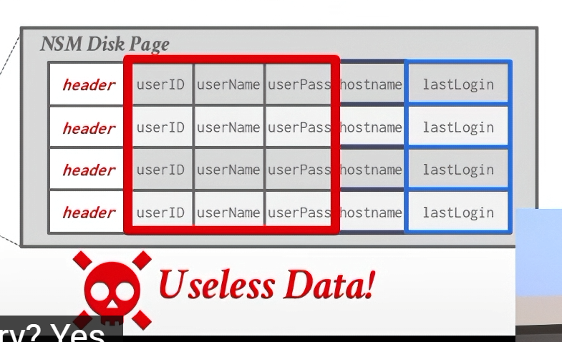
For OLAP workloads, most of the attributes are not needed. But using row storage ensure that we will have to bring the whole page (which contains all attributes of the tuple) from disk to memory adding extra unneeded cost.
It is however good for OLTP workloads (queries that need the entire tuple).
DSM:
Instead of storing all attributes of a tuple in one page, we store each attribute of each tuple in separate pages. All the data for an attribute will be stored in a page contiguously.
Good for reads, OLAP.
Bad for writes and OLTP.
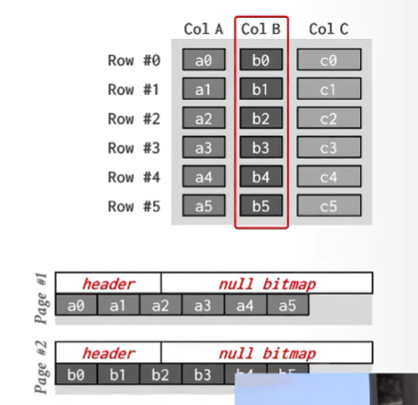
Instead of bringing in all the attributes of a tuple that are stored in one page as in row store.
Now, we only bring in the pages storing data for the needed attributes.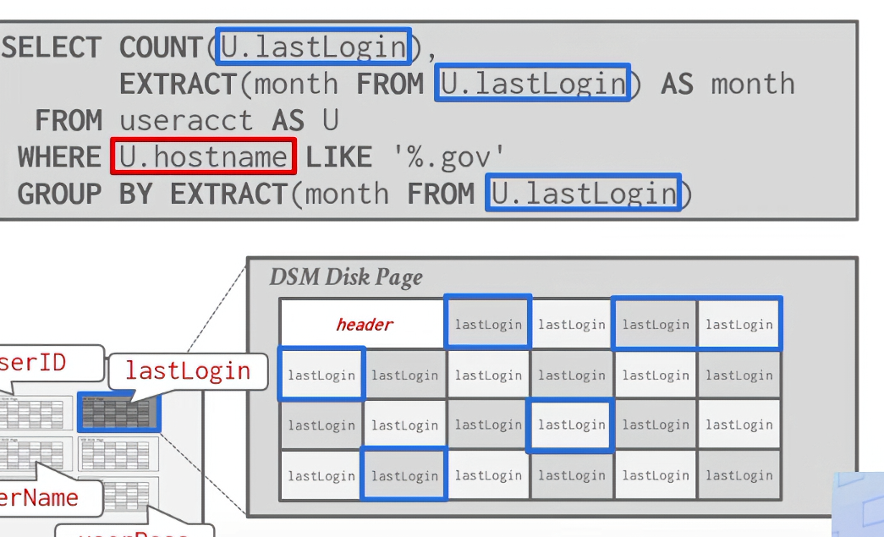
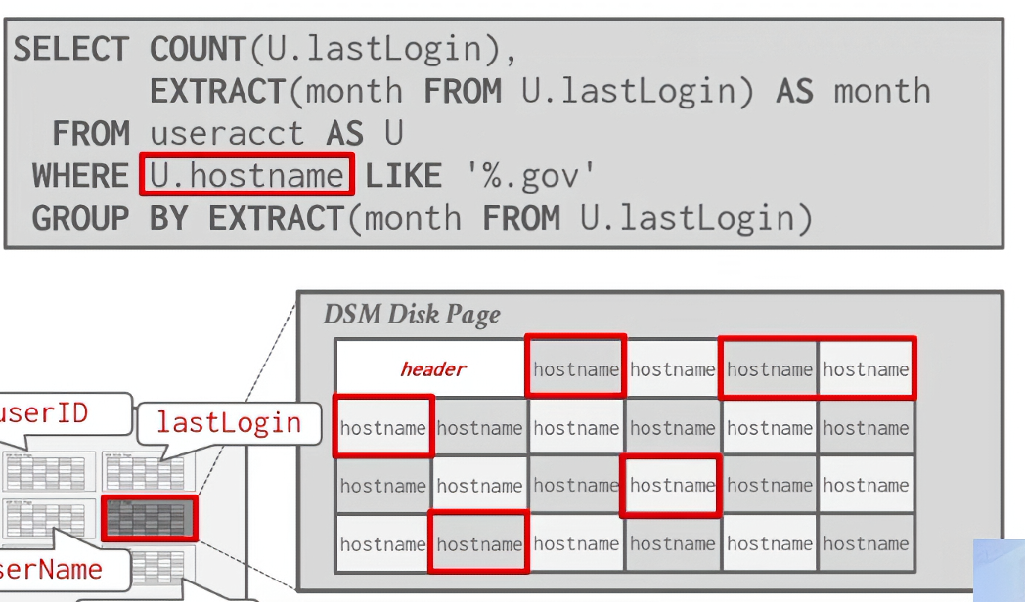

How to identify tuple inside the page?
Two approaches:
- Fixed length offsets: Each val is the same length for an attribute. Directly jump to the offset as we know which tuple’s attribute we are interested in that we know from running the query.
- Embedded tuple ids: Each val is stored with its tuple id embedded into it in a column so you can directly jump to the tuple attribute you need. (This is not practical tried and failed).
Problem?
Even though while running the query, we may not need to access the whole tuple (all attrbs) at some later point the DBMS must get all the other attributes and stitch the tuples back together resulting in a huge overhead.
PAX:
Partition attributes across.
Hybrid storage model that vertically partitions attrbs within a database page.
Combines the faster processing of column store while keeping the spatial locality of row store.
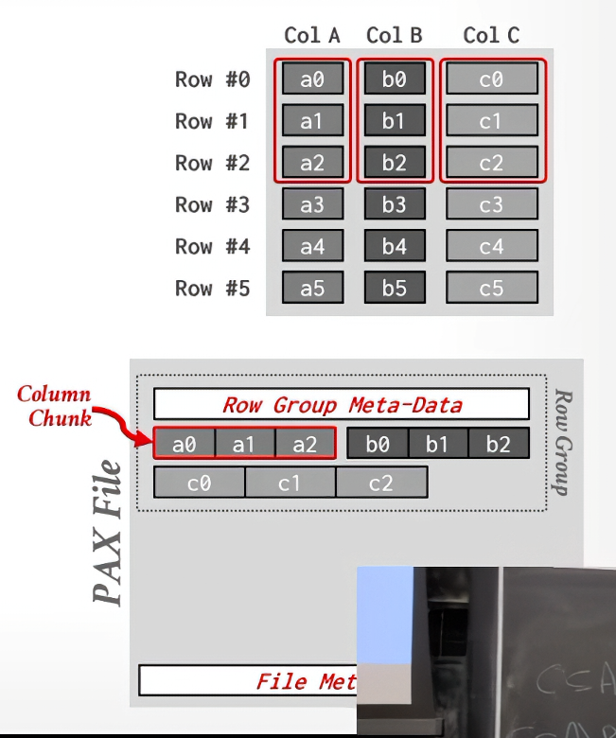

Speed VS Storage:
We can compress pages, when storing to disk.
This would give us lower I/O cost and lower storage overhead
BUT
It would also require more computation power to compress before write and decompress before read.

Database Compression:
We must achieve these goals for our DB compression:
- Compression should produce fixed length values
- Decompression should be postponed as long as possible during query execution (late materialization)
- Compression/Decompressions must be lossless (bits must not be lost hence changing data).
Compression Granularity:
- Block/page-lvl
- Tuple lvl(NSM ONLY)
- Attribute level
- Column level(DSM ONLY)
MYSQL INNODB compression:
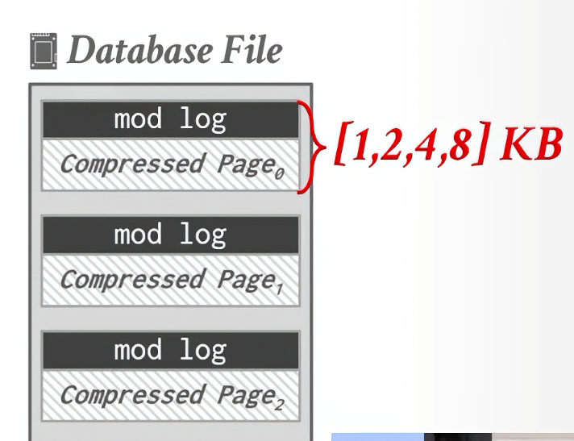
Compressed page is padded upto the given (1,2,4,8 kb) sizes. Mod log can store modifications to apply to the page.
If we want to write/update to the compressed page, we can store that in the mod log instead of decompressing and doing it right then.
Such is not the case with reads;
If the read can be serviced by the modlog, no need to decompress but if not u have to decompress.
If the mod log becomes full, then we decompress the page, apply the changes and compress it again.
This ties in nicely with the concept of delaying decompression.

COLUMN-LVL-COMPRESSION:
- Run length encoding:
Instead of storing the same value over and over again, we store
- Value of attribute
- Start position in the column
- No of elements in the run
Requires sorting of values to be efficient
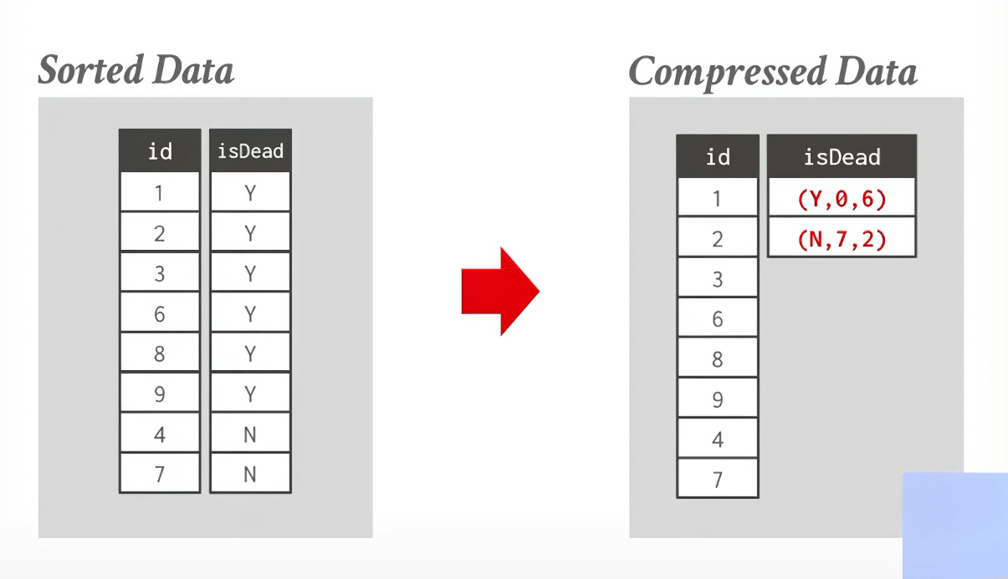
- Bit Packing:
If the values for an int attr are smaller than the range of its assigned data type size, reduce the no of bits to represent the values.
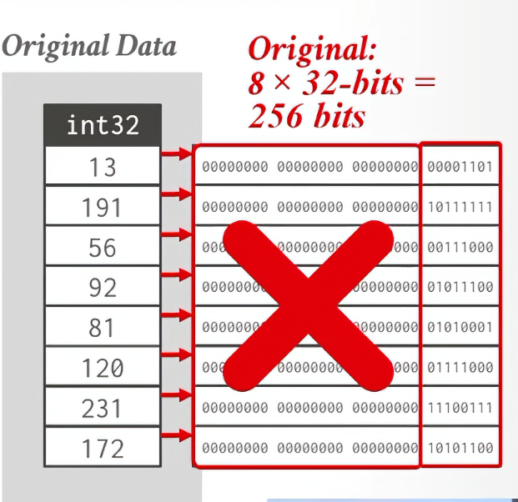
What if a value is then inserted after packing that is larger than the current packed value?
- Patching / Mostly Encoding:
The out of bounds value is stored with a placeholder which directs to its raw form with a special marker to indicate that.
- Bitmap Encoding:
Keep a bitmap for each unique value indicating whether the value is in the tuple(1) or not (0)
Obviously it is only practical if the no of unique values for a given attrb are low. (for eg, isalive or ismarried).
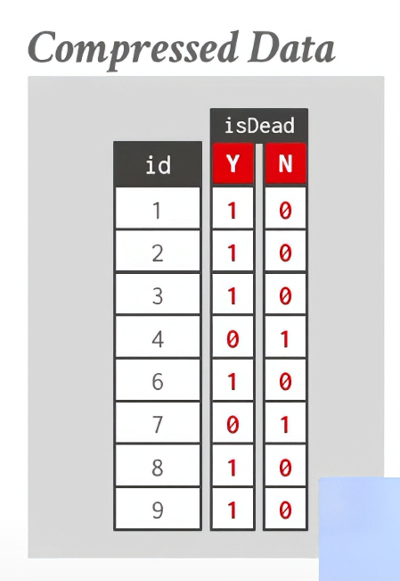

- Delta Encoding:
Record the difference between values that follow each other in the same column. The diff(delta) could be a difference from the previous value or some global value.
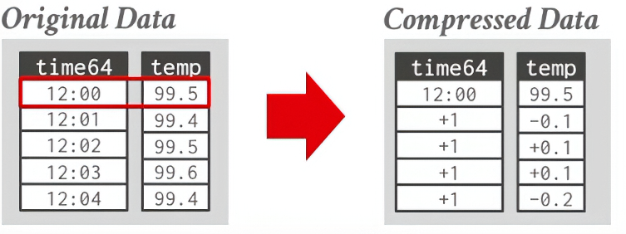
Can further compress with RLE
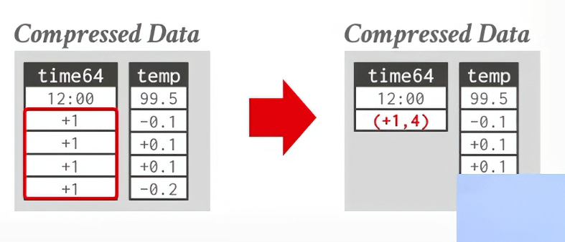
- Dictionary Compression:
Replace frequent values encountered in column with some small fixed length int codes. The codes will stored in mem in a data struct (dictionary) mostly a fixed length array, to map to its actual value.
Allows data comparison in compressed form.
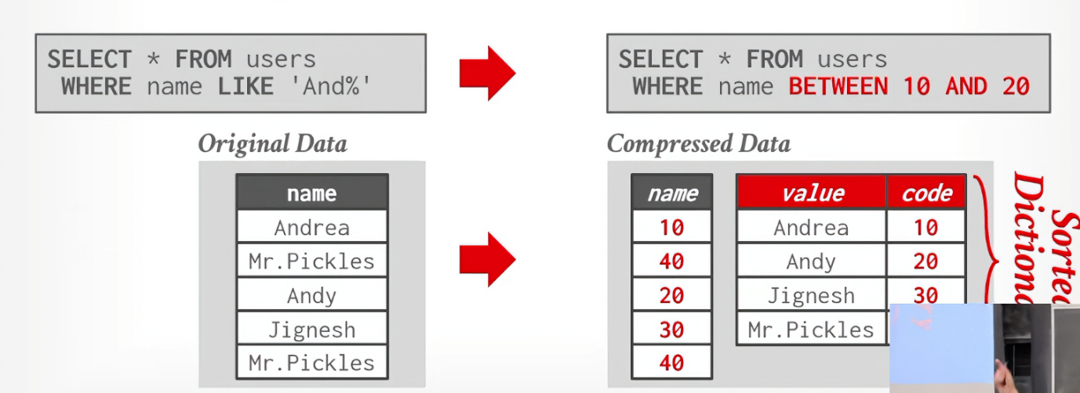
How to ensure only dictionary is used? Use distinct.
